Sharing Documents or Folders

With Google Docs
Now that the Google document has been created, share it with others. The document can be shared from the Docs list or directly from the document.
- From the Documents list, select the checkbox next to the document to be shared (it is also possible to select multiple documents).
- From the document, click the Share drop-down menu in the top right corner of the page.
- Select Invite people…
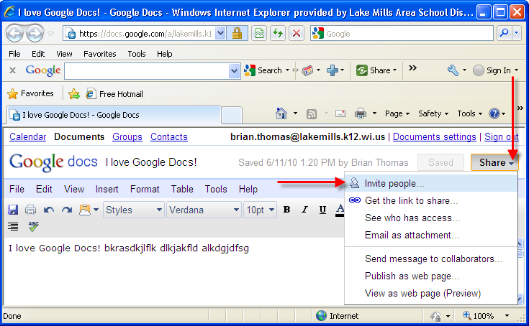

- Select To edit or To view, depending on personal preferences.
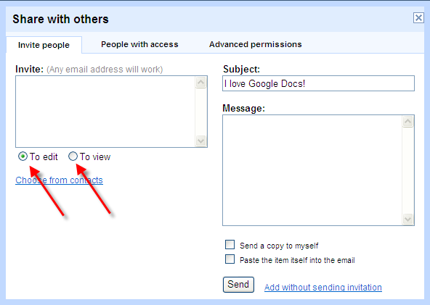

- Enter the email addresses or mailing lists in the Invite field.
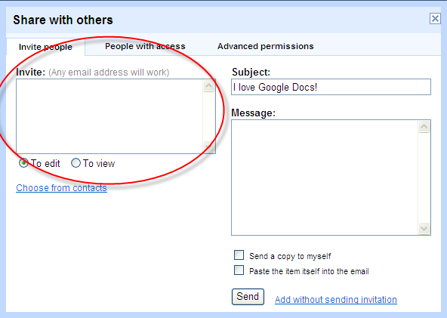

- To add a message to the invitation, enter some text and click Send. To skip sending an invitation, click Add without sending invitation. Collaborators and Viewers will still be able to access the document from their Docs lists, but won't receive an email invitation.
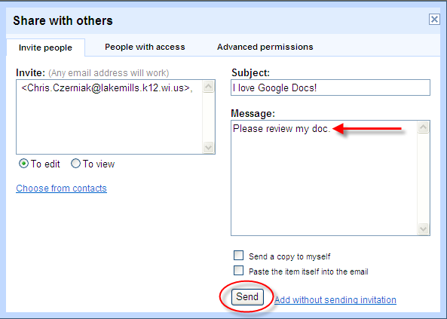

- In the Share window, it is possible to check who has access to the document, remove collaborators and viewers, and change editing rights. The document can be shared with up to 200 combined viewers and collaborators; however, if the document is published, anyone will be able to access it. Up to 10 people may simultaneously edit and/or view a document. Currently User 28 has viewing rights.

Move to the next page to continue this step.

To add everyone in the Lake Mills School District to view or edit, click the down arrow next to the Anyone at Lake Mills Area School District label. A drop down list will appear. Click to select To Edit or To View. Click Save & Close if finished, or continue on to the Advanced permissions tab.
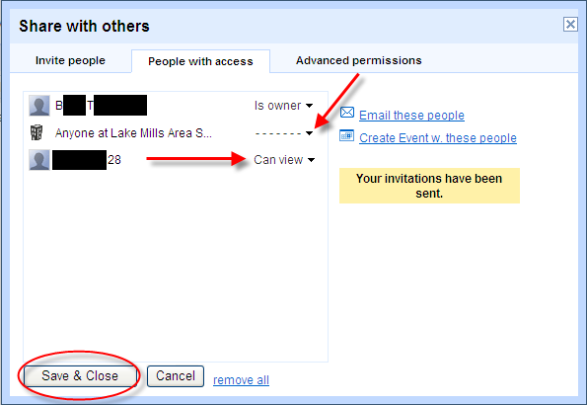

- Click the Advanced permissions tab.
By default, the Allow editors to invite others to edit or view and Allow invitations to be forwarded check boxes are checked. Uncheck both of these boxes to keep control over who has access to the document. Click Save & Close.
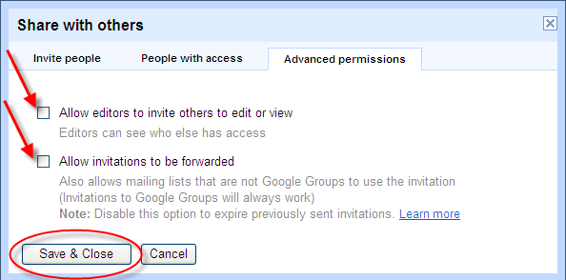
- To get back to these settings at a later point in time, click on Share > See who has access.
- The document is now shared with others. To see if a particular document is shared, go to the Docs list. There is a column named Folders/Sharing that shows the user if the file is located in a folder and if it is shared or not. The file below is located in a folder called documents and it is being shared with 1 viewer.
